1. Go to Transaction SHDO
2. Enter Transaction Code MM01, transaction variant and click on create

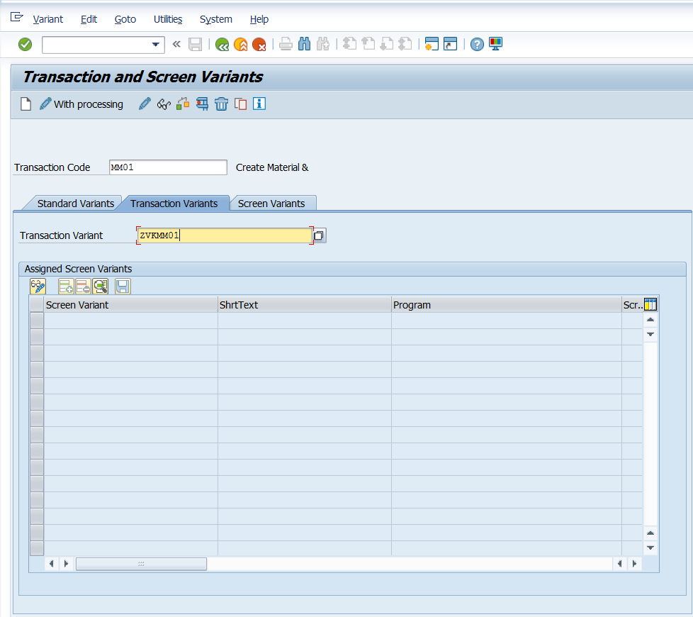

1. Select the required Industry sector and Material Type and press ENTER.

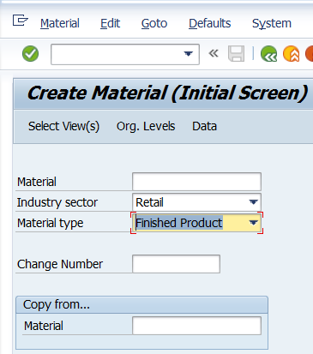

1. Following popup would appear. Make changes as shown below and click on Exit and Save. Observe the name of the screen variant. Alternatively, you can give any name for the screen variant.

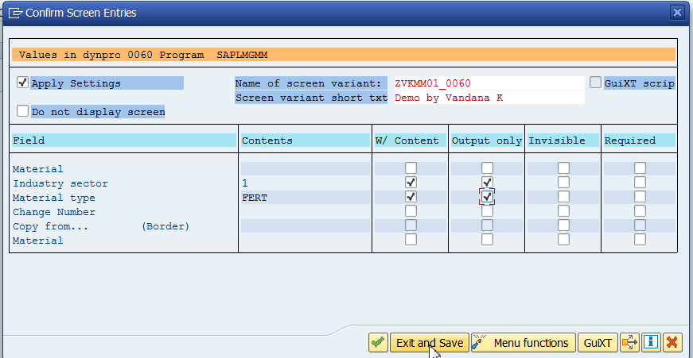

1. Save and press F3 to go back. .

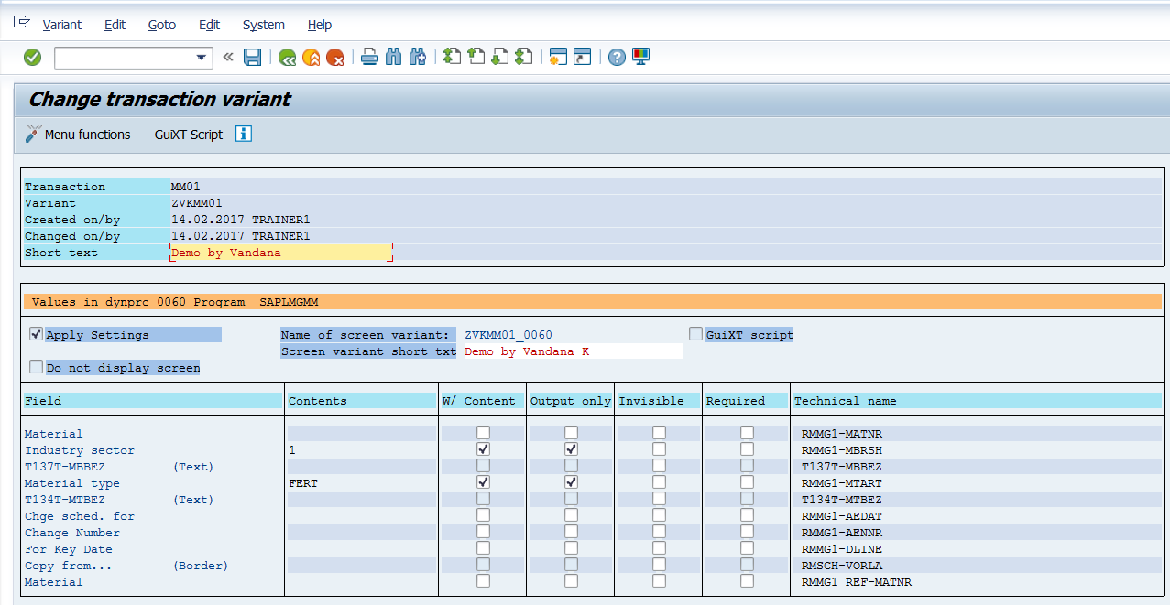

1. Click on change button. Add the screen variant as shown below.

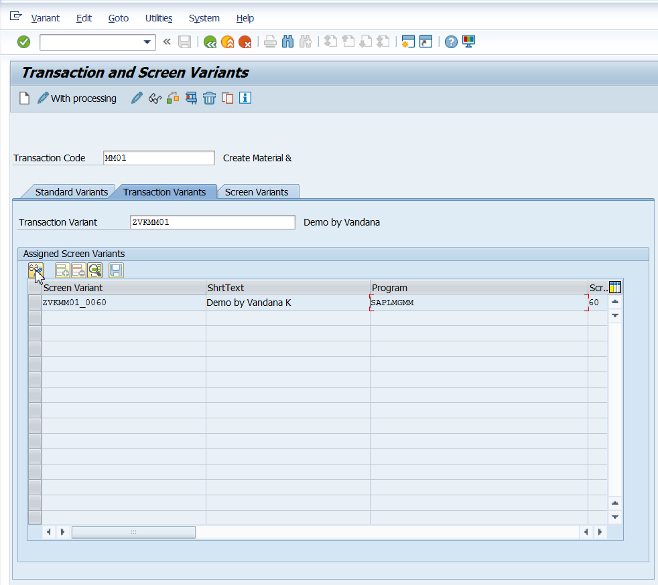

1. Goto Create Variant transaction.

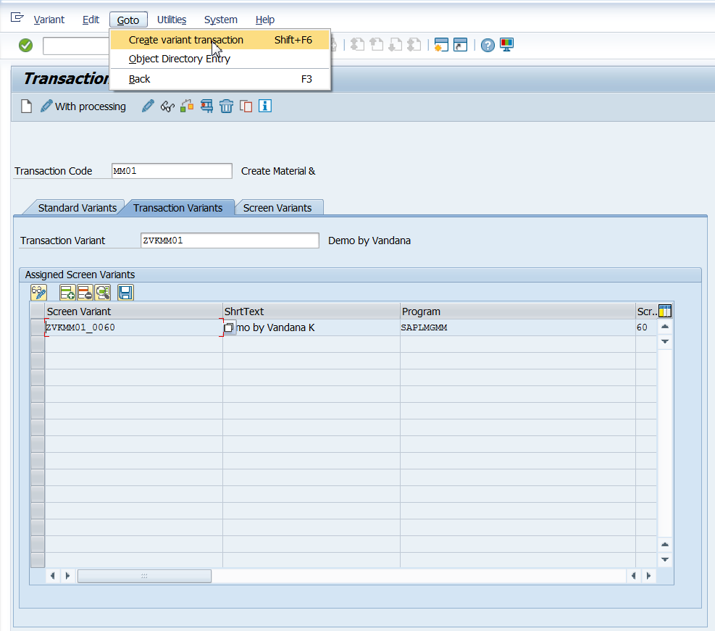

1. Enter transaction code and short text as shown below.

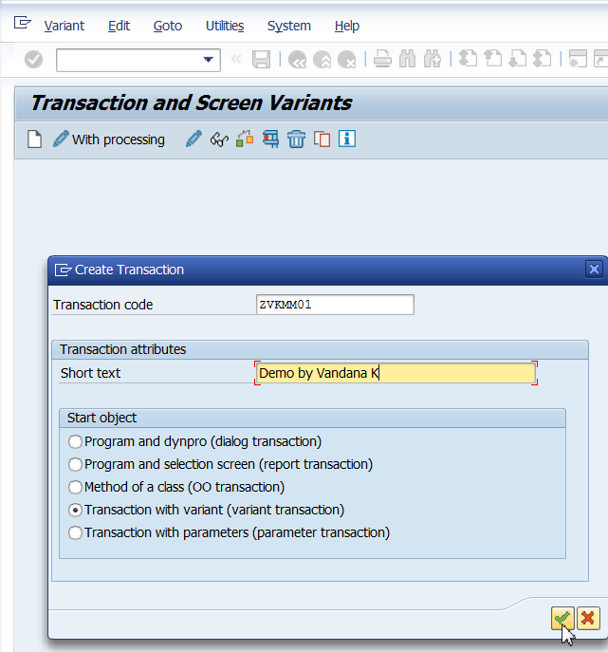

1. The following SE93 transaction would appear. The name of the Transaction Variant is automatically proposed. Save your entries.

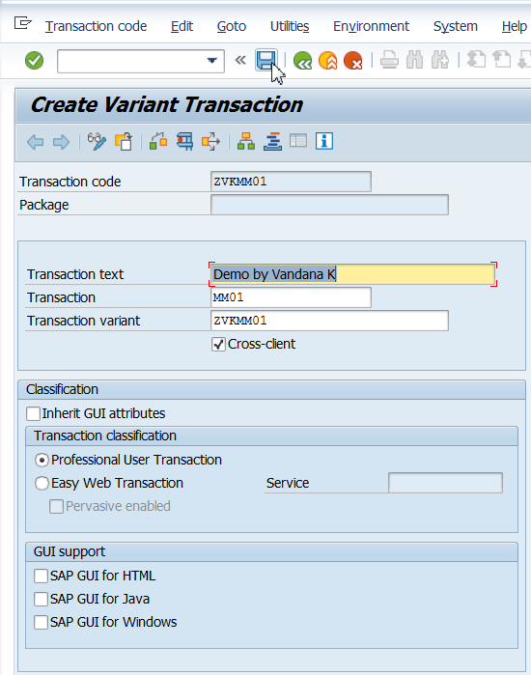

1. Go to transaction ZVKMM01

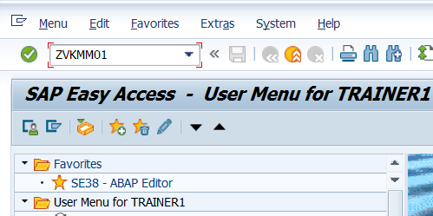

1. Go to transaction ZVKMM01 and check your transaction variant:

You can observe that the field Industry sector and Material type default to the value we have given earlier and are output enabled only.

